Feature available in Linear Gauge:

1. Inputs required
2. Actual Value(Mandatory)
3. Target Value(Mandatory)
4. Min Value (Not Mandatory)
5. Max Value (Not Mandatory)
6. Trend Value1 (Not Mandatory)
7. Trend Value2(Not Mandatory)

In case, if you don’t provide Max value it will calculate Max Value= (Actual value\*2)

1. Percentage formula=Actual\*100/Target;
2. Target line=(((target-min) \*100)/max);

UI Feature:

1.Change colour of Main Bar and Comparison bar

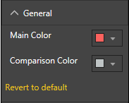

2. Data Label

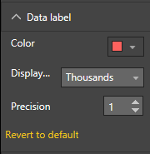

We can change colour of

1. Actual Text
2. Percentage Text
3. Target Text

Display Units and Precision

1. Actual
2. Target
3. Min

Add % in trend value1 and trend value2 

Screen Shot

